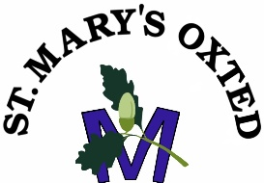  Headteacher  Mrs S Lewis  Email: info@stmarysprimary.org  www.stmarysprimary.org | St. Mary’s C of E (Aided) Primary School  Silkham Road  OXTED  Surrey  RH8 ONP  Tel: 01883 712817  May 2021
Dear Parents/Carers/Guardians

We are delighted that you and your child will be joining our school community in September. Over the next few weeks we will be building up our contact with you so we can prepare to welcome you and your child to the school. Attached are some key dates, and some requests for information.

Thursday 27th May: Virtual meeting for new Parents 5.00pm on Zoom

Reception & Year 3 Tours
Tuesday 15th June and Thursday 17th June
Tuesday 22nd June and Thursday 24th June
There will be two slots to sign up for on each evening between 3.45 and 4.45. Details will be share in the virtual meeting

Tuesday 6th July: Transition day: details for timings will be shared in the virtual meeting

Enclosed with this letter are two forms which should be completed and returned to the School Office by Friday 28th May.

In addition please do download the Class Dojo app and sign up for the ‘new to Reception’ or ‘new to year 3’ group. This will be how we will share message from teachers, and videos you can show your child to help prepare them for joining us.

We look forward to seeing you soon. If you have any questions, please check our website www.stmarysprimary.org which has lots of information for our parents

If circumstances arise that mean you no longer need a place for your child, please let us know as soon as possible as there may be someone waiting for a place.

Yours sincerely
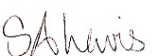
Mrs S Lewis
Head Teacher

